Pre-Work: Coding a Java Web Application

# Pre-Work

The application you’ll be developing in this workshop requires the Eclipse IDE for Java EE Developers (Kepler SR1, linked below), the AWS Toolkit for Eclipse, and a local installation of Tomcat 7. Please be sure you have all of these components installed (instructions below) before the day of the workshop

* Java SE 6+ or OpenJDK 6+.
* Eclipse IDE for Java EE Developers - <http://www.eclipse.org/downloads/packages/eclipse-ide-java-ee-developers/keplersr1>
* Tomcat 7 - <http://tomcat.apache.org/download-70.cgi>
* The AWS Toolkit for Eclipse - <http://aws.amazon.com/eclipse/>
* Maven 2 or 3 - <http://maven.apache.org/download.cgi>

## Eclipse IDE for Java EE Developers

This application has been developed on the Kepler SR1 release of Eclipse. If you have an earlier version of Eclipse and are unable to upgrade, you will need to make sure you have the ‘Maven Integration for Eclipse’ and ‘Maven Integration for Eclipse WTP’ plugins installed. The Kepler SR1 release (linked above) includes these plugins by default.

## Create a Local Tomcat 7 Server

The local Tomcat 7 server will be used for rapid dev/test on your workstation between deploys to your Elastic Beanstalk environment.

1. If you do not have an existing Tomcat 7 server, right-click in the *Servers* pane, choose *New > Server* and complete the wizard to create a new one  
   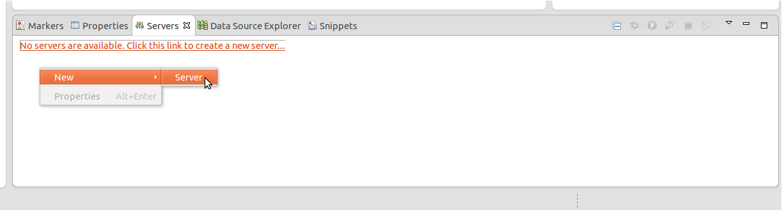
2. Type ‘Tomcat v7’ in the filter box , choose the item and click Next:  
   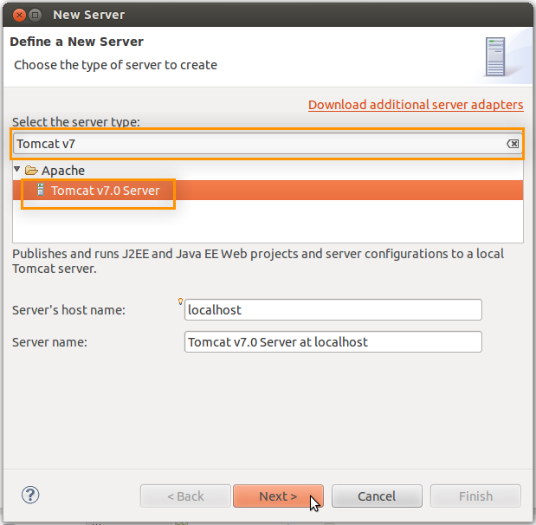
3. Click Download and Install, follow instructions for any licensing agreements, and choose an installation directory.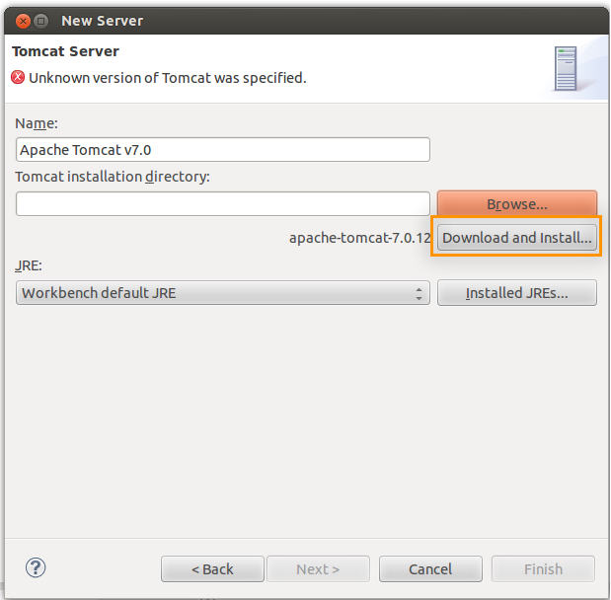

1. Observe the download and installation progress in the bottom-right section of the Eclipse window:  
   

## The AWS Toolkit for Eclipse

The AWS Toolkit for Eclipse allows you to integrate your IDE with Elastic Beanstalk, making it easy to deploy your application a remote environment on AWS. Follow the instructions at <http://aws.amazon.com/eclipse/> to install the toolkit.